# Quick Start Guide

How to configure cross compiler build environment and how to build PiZeroCam project.

## Create VM

1. Launch Hyper-V Quick Create app:  
   Graphical user interface

   Description automatically generated
2. Select Ubuntu 20.04 and click Create Virtual Machine:  
   Graphical user interface, text, application

   Description automatically generated
3. When done you should get this message:  
   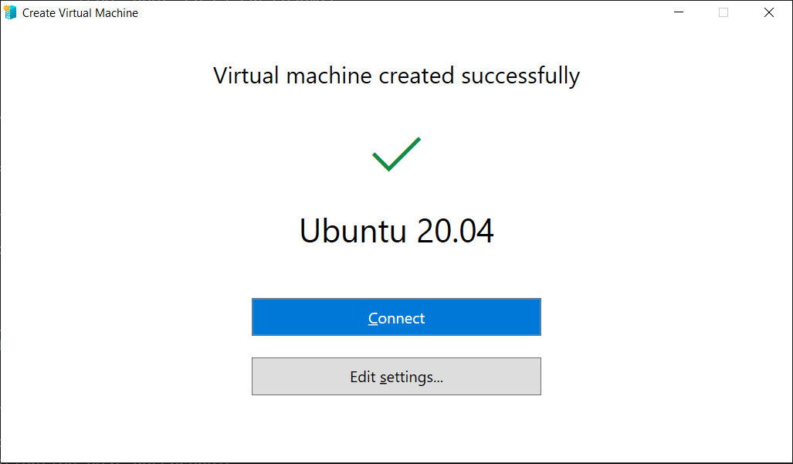  
   Press *Edit Settings* button, in left pane navigate to *SCSI Controller | Hard Drive*, click *Edit* button under *Virtual Hard Disk* option. *Virtual Hard Disk Wizard* appears. Click *Next*>>. Select *Expand*. Enter *New size* at least 50 GB.
4. Press Connect button to connect to VM. Then press Start. Proceed configuring Ubuntu usual way.
5. Install *gparted* by running command:  
    ***sudo apt install gparted***
6. Run *gparted* and resize sda1 partition to full size:  
   Graphical user interface

   Description automatically generated

## Install Software on VM

Execute the following commands one by one or place them into a shell script and execute whole shell script (this script is also available here: [PiZeroCam/mysetup.sh](https://github.com/vlad-nn/PiZeroCam/blob/main/tools/mysetup.sh)).

echo ----- Installing FAR

sudo add-apt-repository -y ppa:far2l-team/ppa

sudo apt -qq update

sudo apt -qq install far2l

echo ----- Installing CMake

sudo apt -qq install cmake

echo ----- Installing VS Code

sudo snap install code --classic

echo ----- Installing git

sudo apt -qq install git-all

echo ----- Installing gcc for ARM

sudo apt -qq install g++-arm-linux-gnueabi

echo ----- Installing clang-format-9

sudo apt -qq install clang-format-9

echo ----- Installing xrdp

sudo apt -qq install xrdp

sudo adduser xrdp ssl-cert

echo gnome-session > ~/.xsession

echo ----- Installation done for host:

cat /etc/hostname

## Notes on xrdp Operation

It is convenient to login into VM using Remote Desktop app (and RDP protocol), and not Hyper-V built-in window, because Hyper-V window does not support clipboard exchange between host OS and VM.

However, sometimes RDP does not work. The following fix enables RDP:

1. Open ***/etc/xrdp/xrdp.ini*** file in any text editor
2. Find ***use_vsock=…*** line
3. Change it to opposite. For example ***use_vsock=true*** to ***use_vsock=false***
4. Save the file
5. Restart xrdp service or simply reboot VM

## Configure VS Code (optional)

Perform this step if you want to work (build and develop) from VS Code.

1. Click on plugin button  and install C/C++ plugin from Microsoft:  
   Graphical user interface, text, application

   Description automatically generated
2. Install CMake Tools plugin from Microsoft:  
   A picture containing logo

   Description automatically generated

## Build Project

1. Create a directory (in this example, ***mydev***) in your home directory:  
   cd ~  
   mkdir mydev  
   cd mydev
2. Clone repo:  
   git clone https://github.com/vlad-nn/PiZeroCam.git
3. Create build subdirectory:  
   cd PiZeroCam  
   mkdir build
4. Build project:  
   cmake ..  
   make
5. Build artifacts of ***userland*** project are stored in ***build/userland_build*** directory. They include command line utilities like raspistill and raspivid to capture still images and video from Pi camera. They can be used to evaluate build results.
6. Build artifacts of TFLite project (namely, libtensorflow-lite.a) are stored in ***build/third_party/tensorflow/tensorflow/lite*** directory